Project Design Phase
Problem – Solution Fit Template

Date | 02 NOVEMBER 2025
Team ID | NM2025TMID02363
Project Name | Laptop Request Catalog Item
Maximum Mark | 2 Marks

Problem – Solution Fit Template

The Problem–Solution Fit ensures that the solution effectively addresses a specific customer problem and provides measurable improvements in their experience and workflow. It helps validate that the proposed feature not only solves the issue but also aligns with user needs and behavior.
Purpose:

- Solve workflow inefficiencies in requesting and approving laptops through the service catalog.
- Increase productivity and reduce manual errors by automating request handling.
- Provide transparency with real-time request tracking and status updates.
- Reduce waiting times through guided forms and auto-approval conditions.
- Enhance employee satisfaction by simplifying the overall laptop request experience.

Problem:
Employees face difficulties and delays when requesting laptops through manual or nonintuitive processes. The lack of dynamic forms, auto-validation, and tracking leads to confusion and follow-up delays. Admins often receive incomplete or incorrect requests, slowing down approvals and causing frustration for both users and support teams.
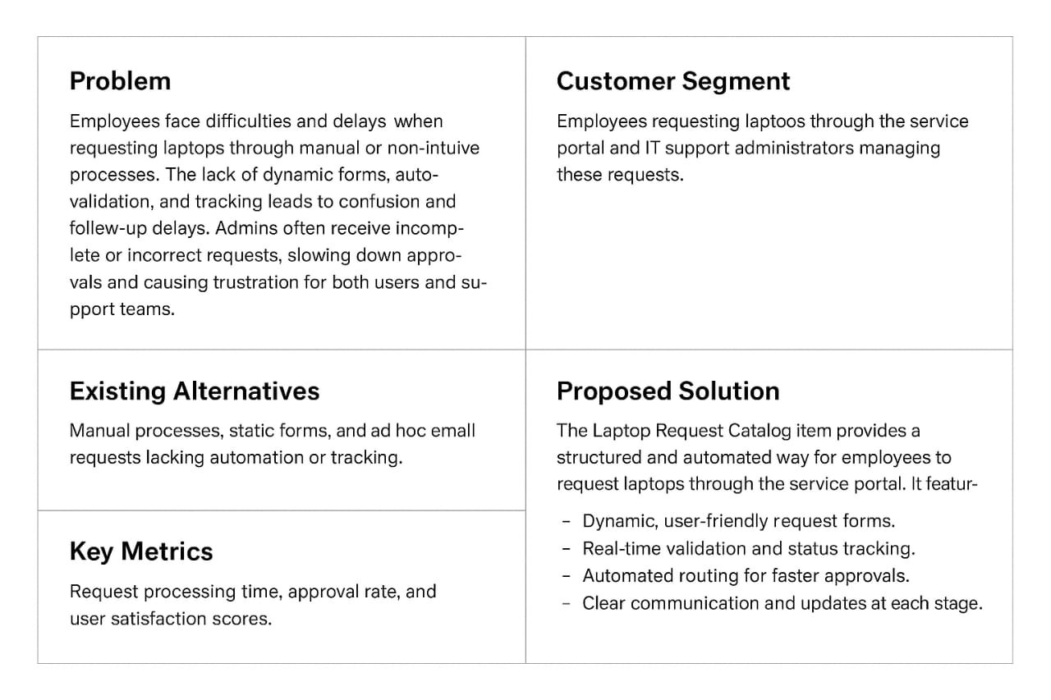
Solution:
The Laptop Request Catalog Item provides a structured and automated way for employees to request laptops through the service portal. It features:
- Dynamic, user-friendly request forms.
- Real-time validation and status tracking.
- Automated routing for faster approvals.
- Clear communication and updates at each stage.
This solution improves accuracy, reduces turnaround time, and boosts user confidence in the IT service management process.

References:
- https://www.ideahackers.network/problem-solution-fit-canvas/
- https://medium.com/@epicantus/problem-solution-fit-canvas-aa3dd59cb4f

